CSIT314 Software Development Methodologies - Group Project

Sprint 3 - US23: Delete current IDP
Interior Design Platform - Interior Designer
All diagrams were drawn in draw.io. Open "US23 Delete current IDP.drawio" in this folder to edit them - each diagram is its own page in that file. The exported images are in the "diagrams" folder.

Assumptions
- The system is the Interior Design Platform from the project specification. Sprint 3 covers the Interior Designer's current IDP stories (add, view, update, delete and search, US20 - US24) and the Customer's log in, IDP search, IDP view and log out stories (US30 - US32, US36).
- We follow B-C-E: the actor only talks to the boundary (page), the boundary only talks to the controller, and the controller works with the entity classes. There is one controller per use case.
- The boundary checks all the input (required fields, lengths, formats, e.g. not suspending your own profile) and trims spaces, then passes an entity object on. The controller just calls the entity and returns the result. The entity checks for duplicates and the database state (e.g. name already used, only Active rows are changed), then saves. In US23 there is no typed input to check: the page passes the session owner and the idpId from the URL on, the controller just calls the entity, and the entity only suspends the owner's Active Current IDP whose category is Active.
- An IDP is an interior design project. A current IDP is one the designer is still working on (US20 - US24); a past IDP is a completed one (US25 onwards). Both are rows in the idp table with projectType Current or Past.
- Logged in as an interior designer (UC13) is the precondition. designerLoginRequired in app.py only sends someone with no session to /designer/login; the use case doesn't check the designer again (no InteriorDesignerLoginController).
- Delete is a soft delete, the same as deleting a company profile (US17): the IDP's status becomes Suspended and its details are kept. It then no longer shows in the list, the preview, update, search or to customers.
- "Delete current IDP" on the preview (US21) loads the IDP with the controller's own loader getCurrentIDP(designerId, idpId) and only opens a confirmation box that names it - nothing is deleted until the designer confirms. If it isn't the designer's Active Current IDP in an Active category, the system shows "Current IDP not found" (HTTP 404).
- The box posts choice "delete" or "cancel". There is no confirmation token, the details are not compared and nothing is kept in the session: the entity's check (owner, Current, Active, Active category) is enough. An IDP edited (US22) after the box was opened can still be deleted.
- Deleted: back to Current IDPs with "Current IDP deleted successfully". Not deleted because the IDP is no longer available (e.g. already deleted): "Current IDP not found" (HTTP 404). Cancel: back to the preview, nothing changes. There is no restore in this story.

1. User story
Story ID | US23
User story | As an interior designer, I want to delete a current IDP so that it is no longer shown on the platform.
Actor | Interior Designer
Priority | Medium
Story points (estimate) | 3
Acceptance criteria | 1. Given I am viewing my current IDP, when I click "Delete current IDP", then a box asks "Are you sure you want to delete <title>?" and nothing is deleted yet.  2. Given I click "Delete current IDP" in the box, then the IDP is set to Suspended (its details are kept) and I go back to Current IDPs with "Current IDP deleted successfully".  3. Given I click "Cancel", then I go back to the preview and nothing changes.  4. Given the IDP is deleted, then it is no longer in my list or search, and its preview, update and delete links give "Current IDP not found" (HTTP 404).  5. Given the IDP is missing, not mine, Past, Suspended or in a Suspended category, then I see "Current IDP not found" (HTTP 404) and nothing is deleted.
Tasks | T23.1 Write the use case description and draw the use case diagram  T23.2 Draw the B-C-E class diagram and the sequence diagram  T23.3 Draw the wireframes for the delete button, the confirmation box, the result and not found  T23.4 Write the unit tests first (TDD) for IDP, DeleteCurrentIDPController and DeleteCurrentIDPPage  T23.5 Code IDP.suspendCurrentIDP(designerId, idpId) (owner's Active Current IDP in an Active category)  T23.6 Code DeleteCurrentIDPController (getCurrentIDP loader, deleteCurrentIDP - just calls the entity)  T23.7 Code DeleteCurrentIDPPage, the confirmation box and the preview button  T23.8 Run the test cases, fix bugs and push to the repo so the CI pipeline runs the unit tests

2. Use case diagram
The user story becomes one use case, UC23 Delete current IDP. The Interior Designer is the only actor. The confirmation, Cancel and not-found results are flows of this use case.
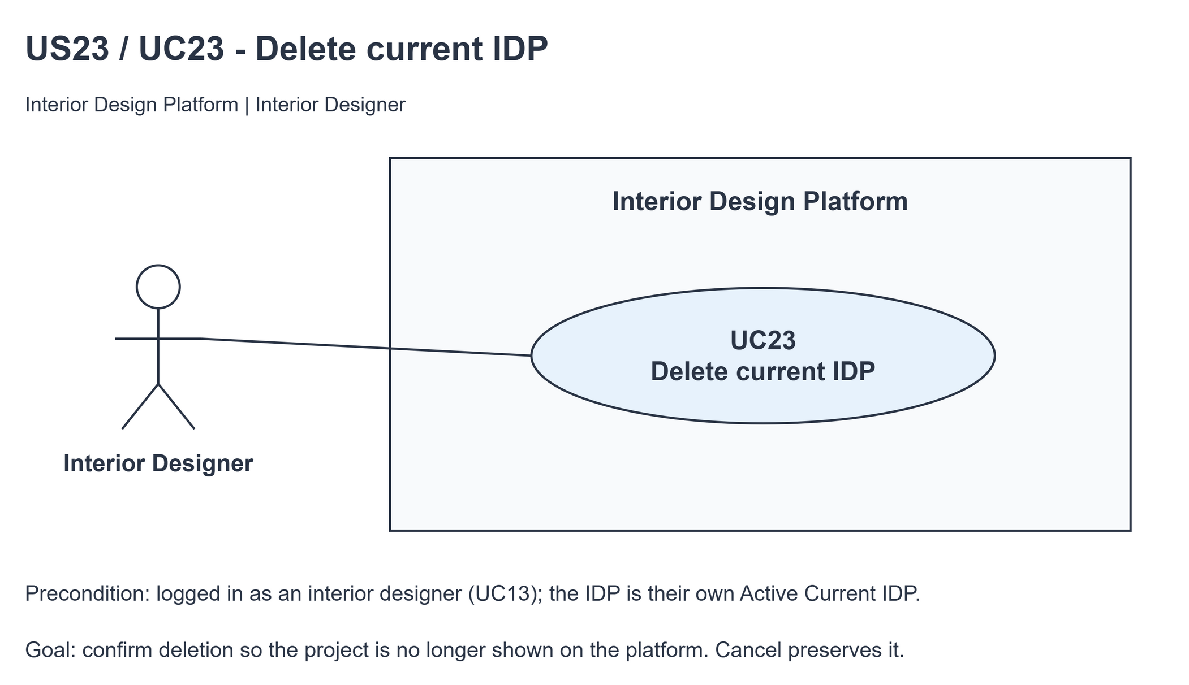
Figure 1: Use case diagram for US23 Delete current IDP

3. Use case description
Use case | UC23 Delete current IDP
Actor | Interior Designer
Brief description | The Interior Designer deletes a current IDP so it is no longer shown on the platform. The row is kept as Suspended.
User story | US23: As an interior designer, I want to delete a current IDP so that it is no longer shown on the platform.
Preconditions | The Interior Designer is logged in (UC13). designerLoginRequired in app.py only sends someone with no session to /designer/login.  The IDP is the designer's own Active Current IDP in an Active category (UC20).
Trigger | The Interior Designer clicks "Delete current IDP" on the IDP's preview (UC21).
Basic flow | 1. The Interior Designer clicks "Delete current IDP".  2. The system loads the designer's Active Current IDP.  3. The system shows a confirmation box naming the IDP.  4. The Interior Designer clicks "Delete current IDP" in the box.  5. The system sets the IDP to Suspended if it is still the designer's Active Current IDP in an Active category. Its details are kept.  6. The system shows Current IDPs with "Current IDP deleted successfully".
Alternative flows | 2a. The IDP is missing, someone else's, Past, Suspended or in a Suspended category: the system shows "Current IDP not found" (HTTP 404). The use case ends.  4a. The Interior Designer clicks "Cancel": the system goes back to the preview. Nothing changes.  5a. The IDP is no longer available (e.g. it was already deleted or its category was suspended): the system shows "Current IDP not found" (HTTP 404). Nothing changes.
Postconditions | The IDP row and its details are kept as Suspended; it is no longer shown on the platform. Other IDPs, categories and accounts are unchanged.

4. Wireframes
The wireframes were drawn in draw.io. They are low-fidelity: they show the layout and the flow, not the final colours.

4a - Delete action on the preview
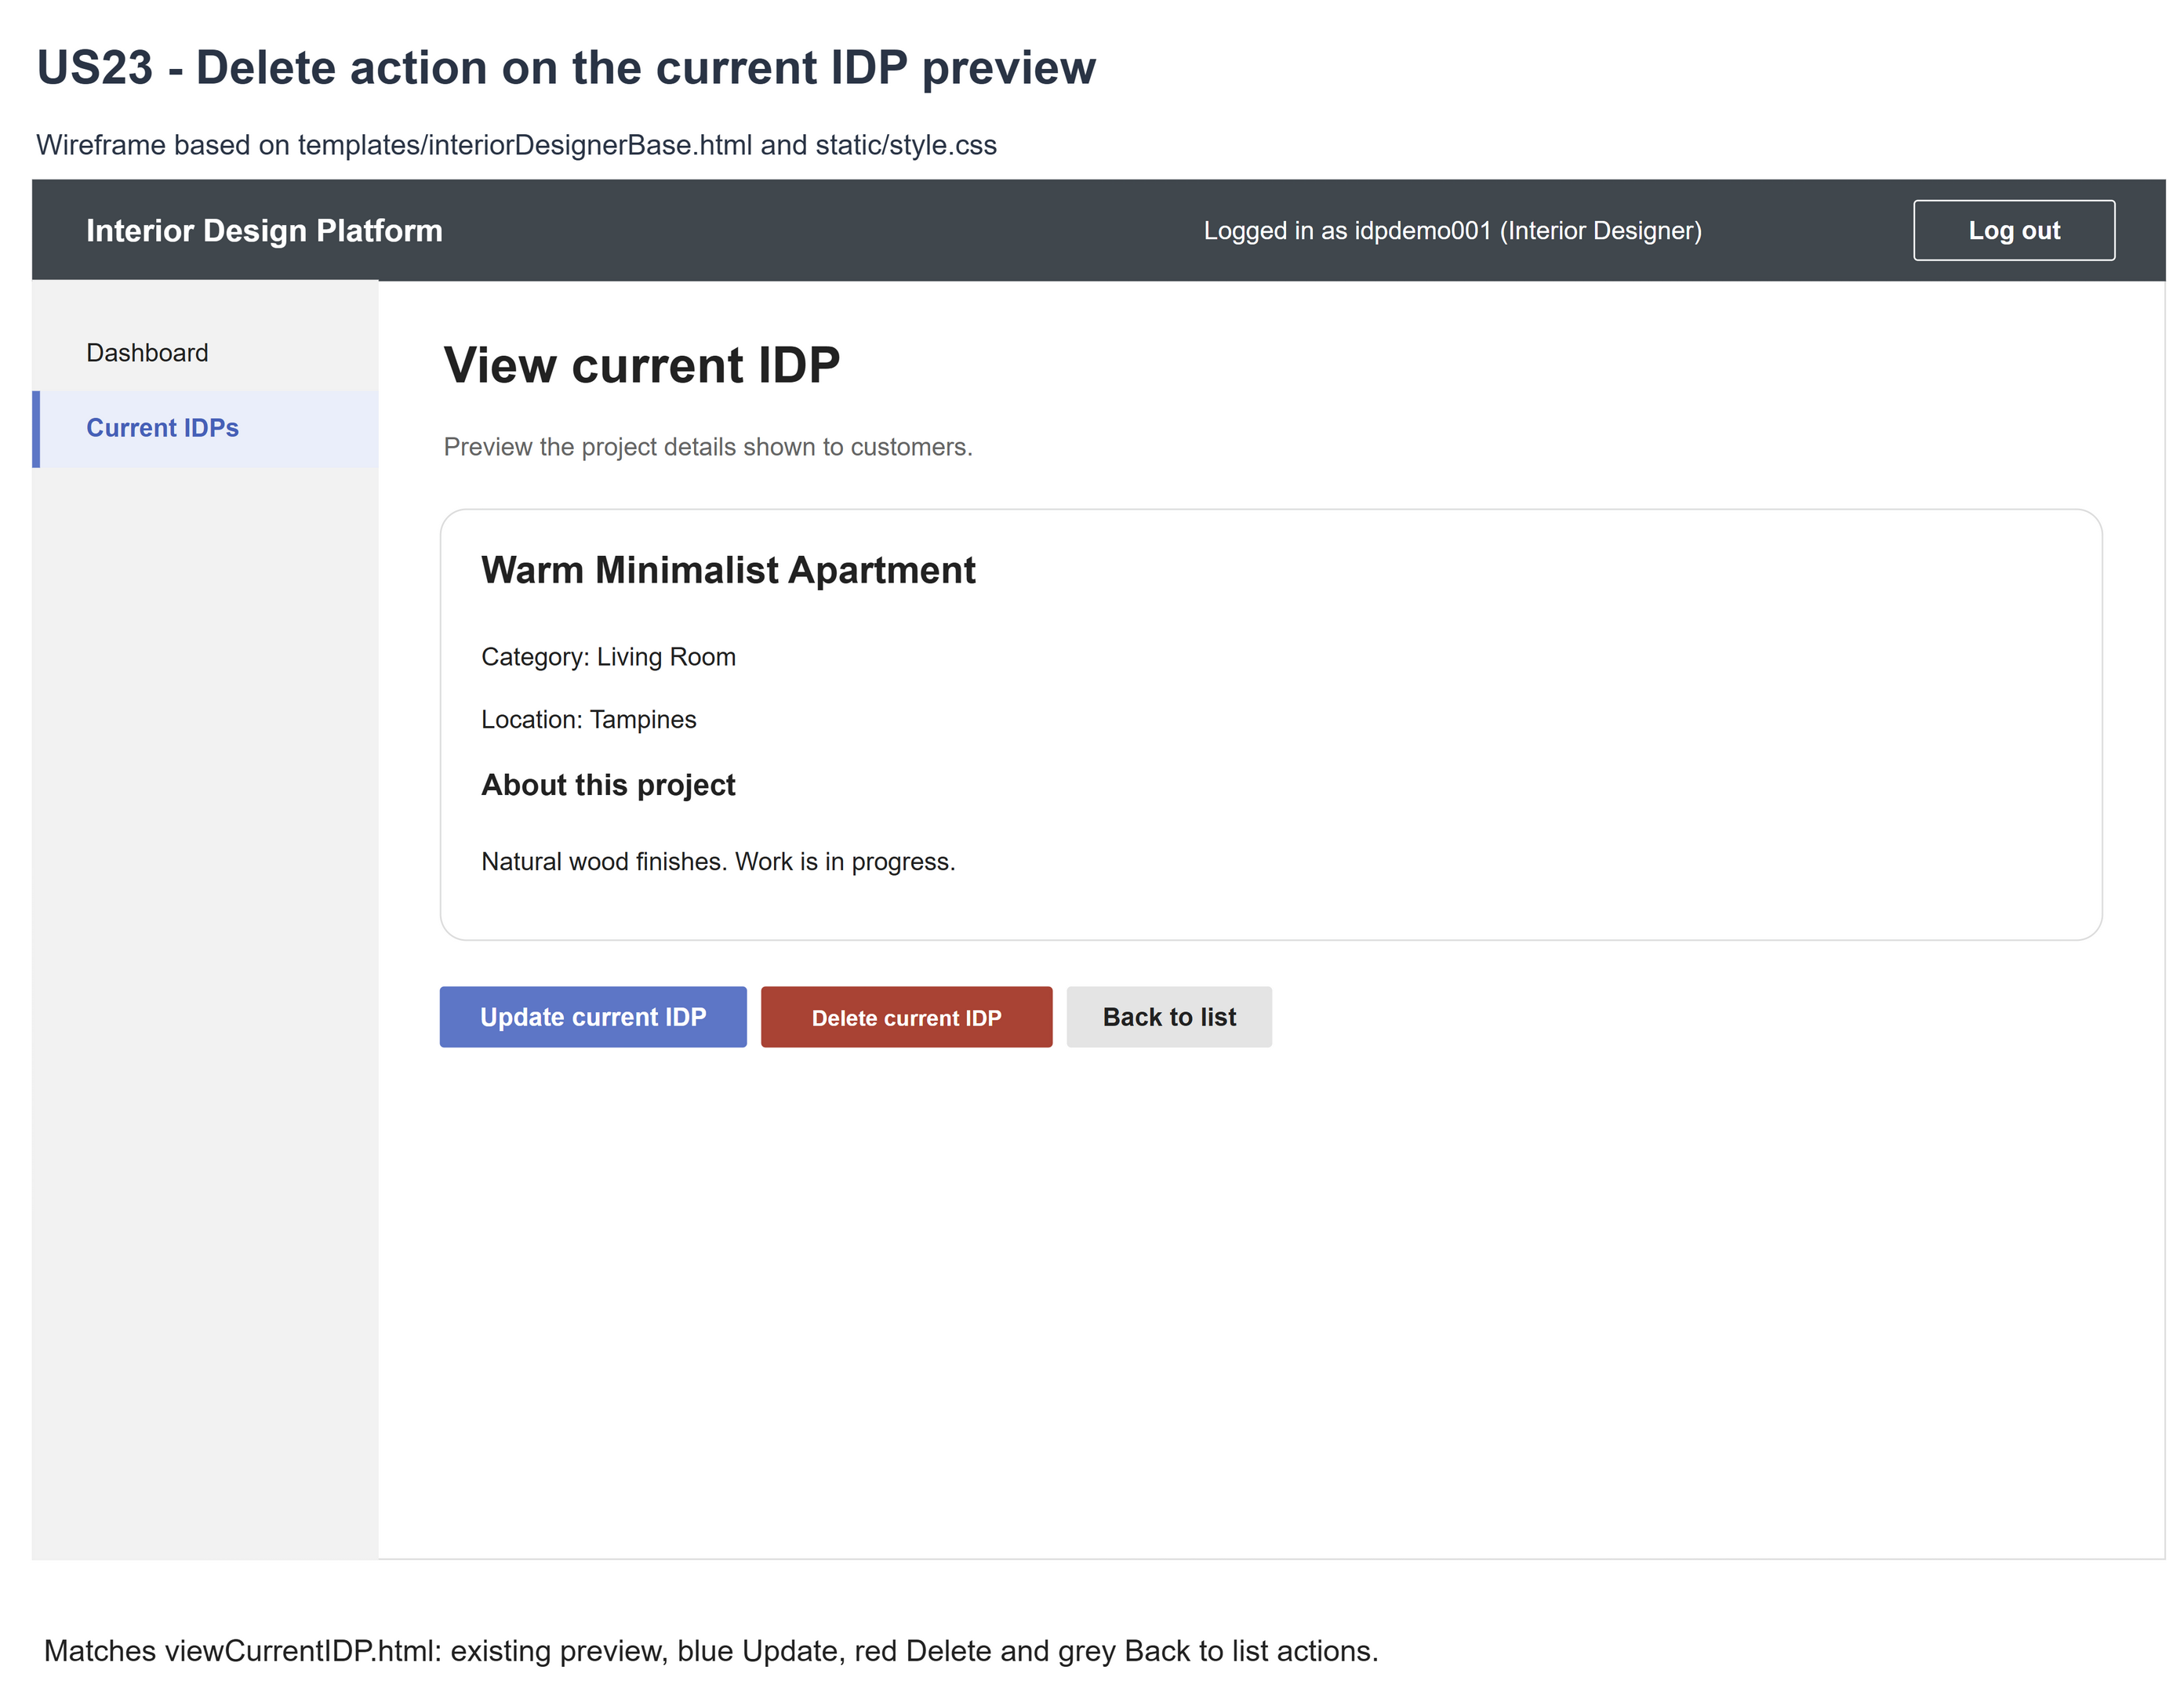
Figure 2: Wireframe 4a - Delete action (US23)

4b - Delete confirmation
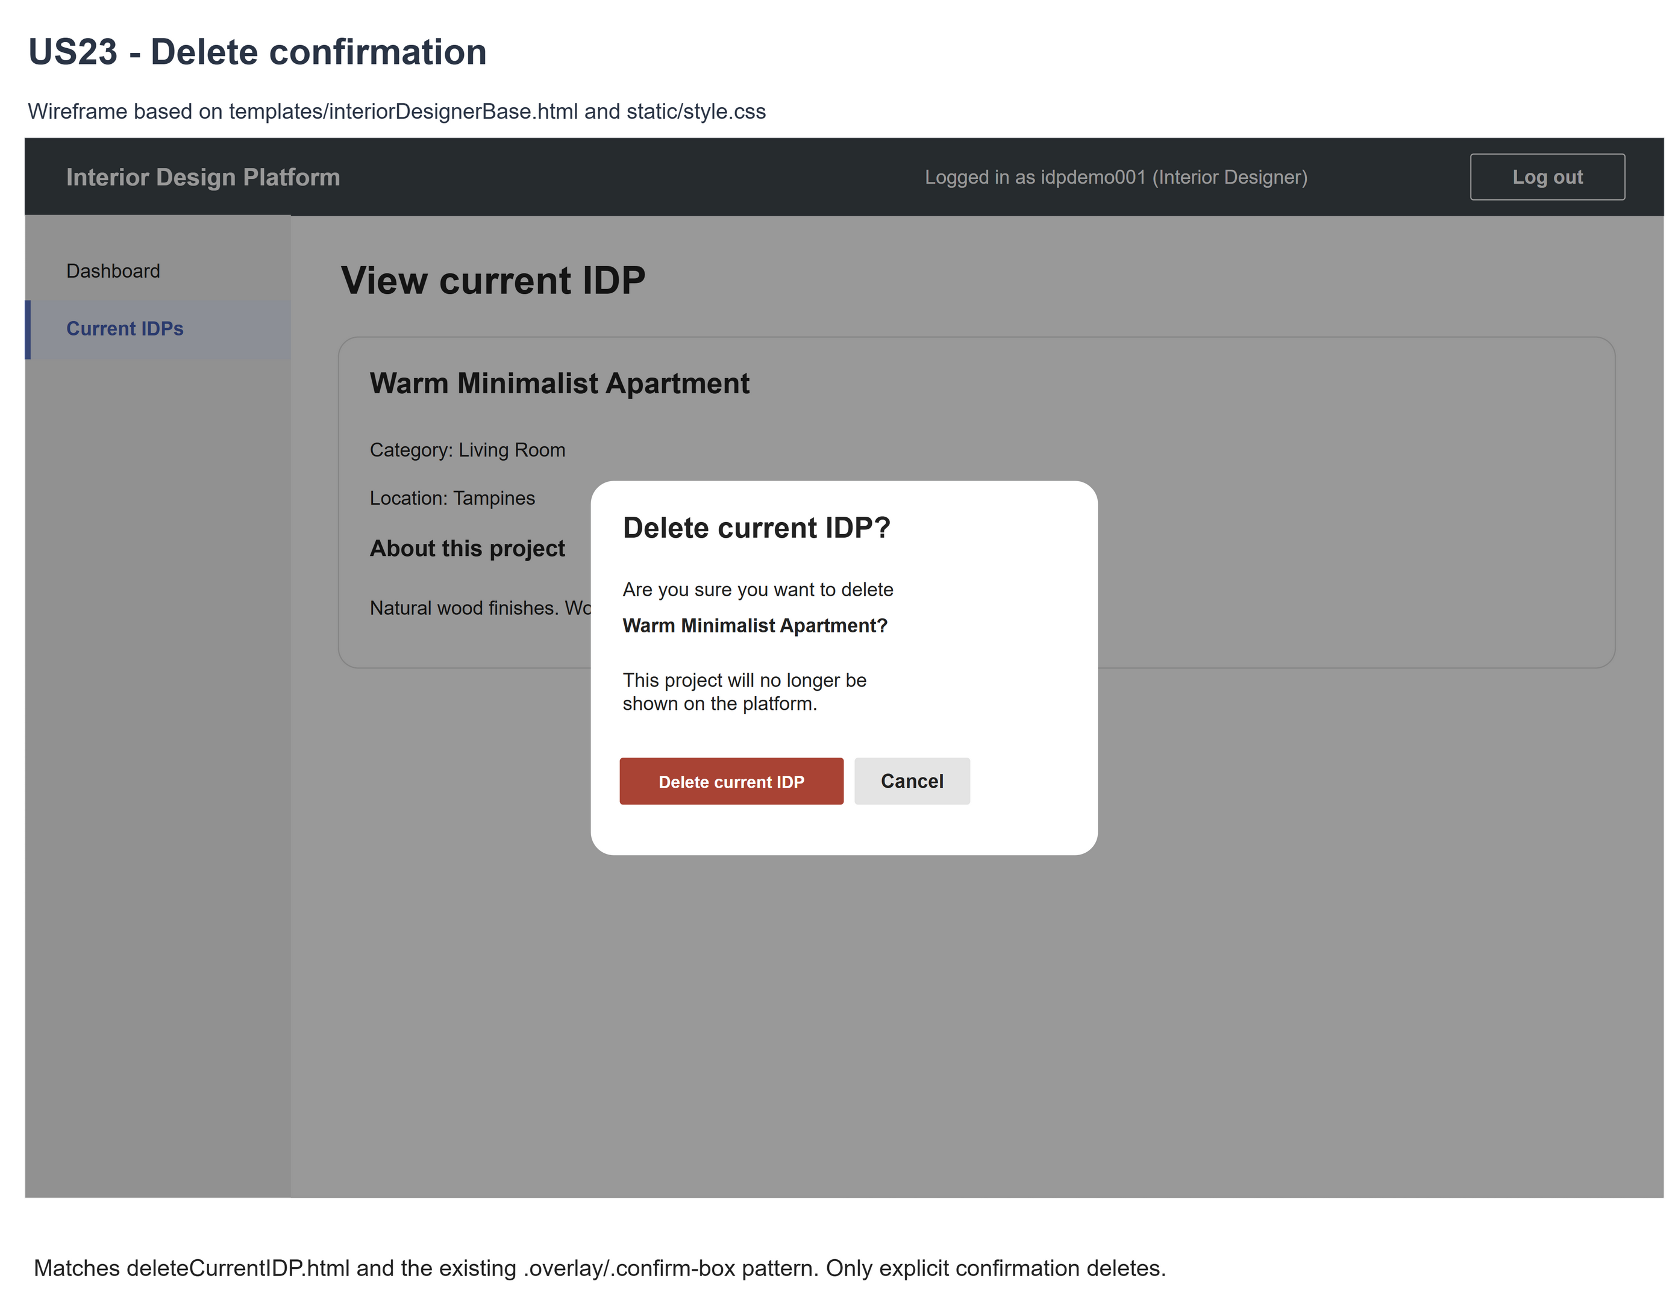
Figure 3: Wireframe 4b - Delete confirmation (US23)

4c - Successful deletion
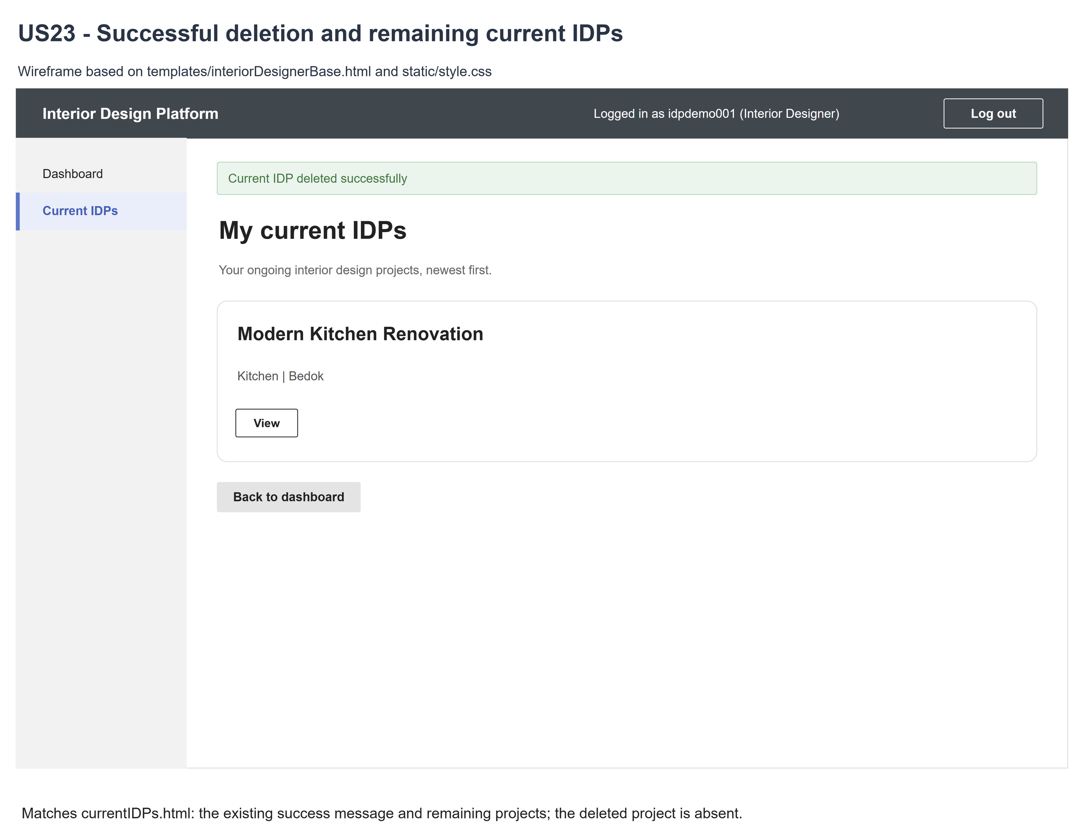
Figure 4: Wireframe 4c - Deletion result (US23)

4d - Deleted IDP not found
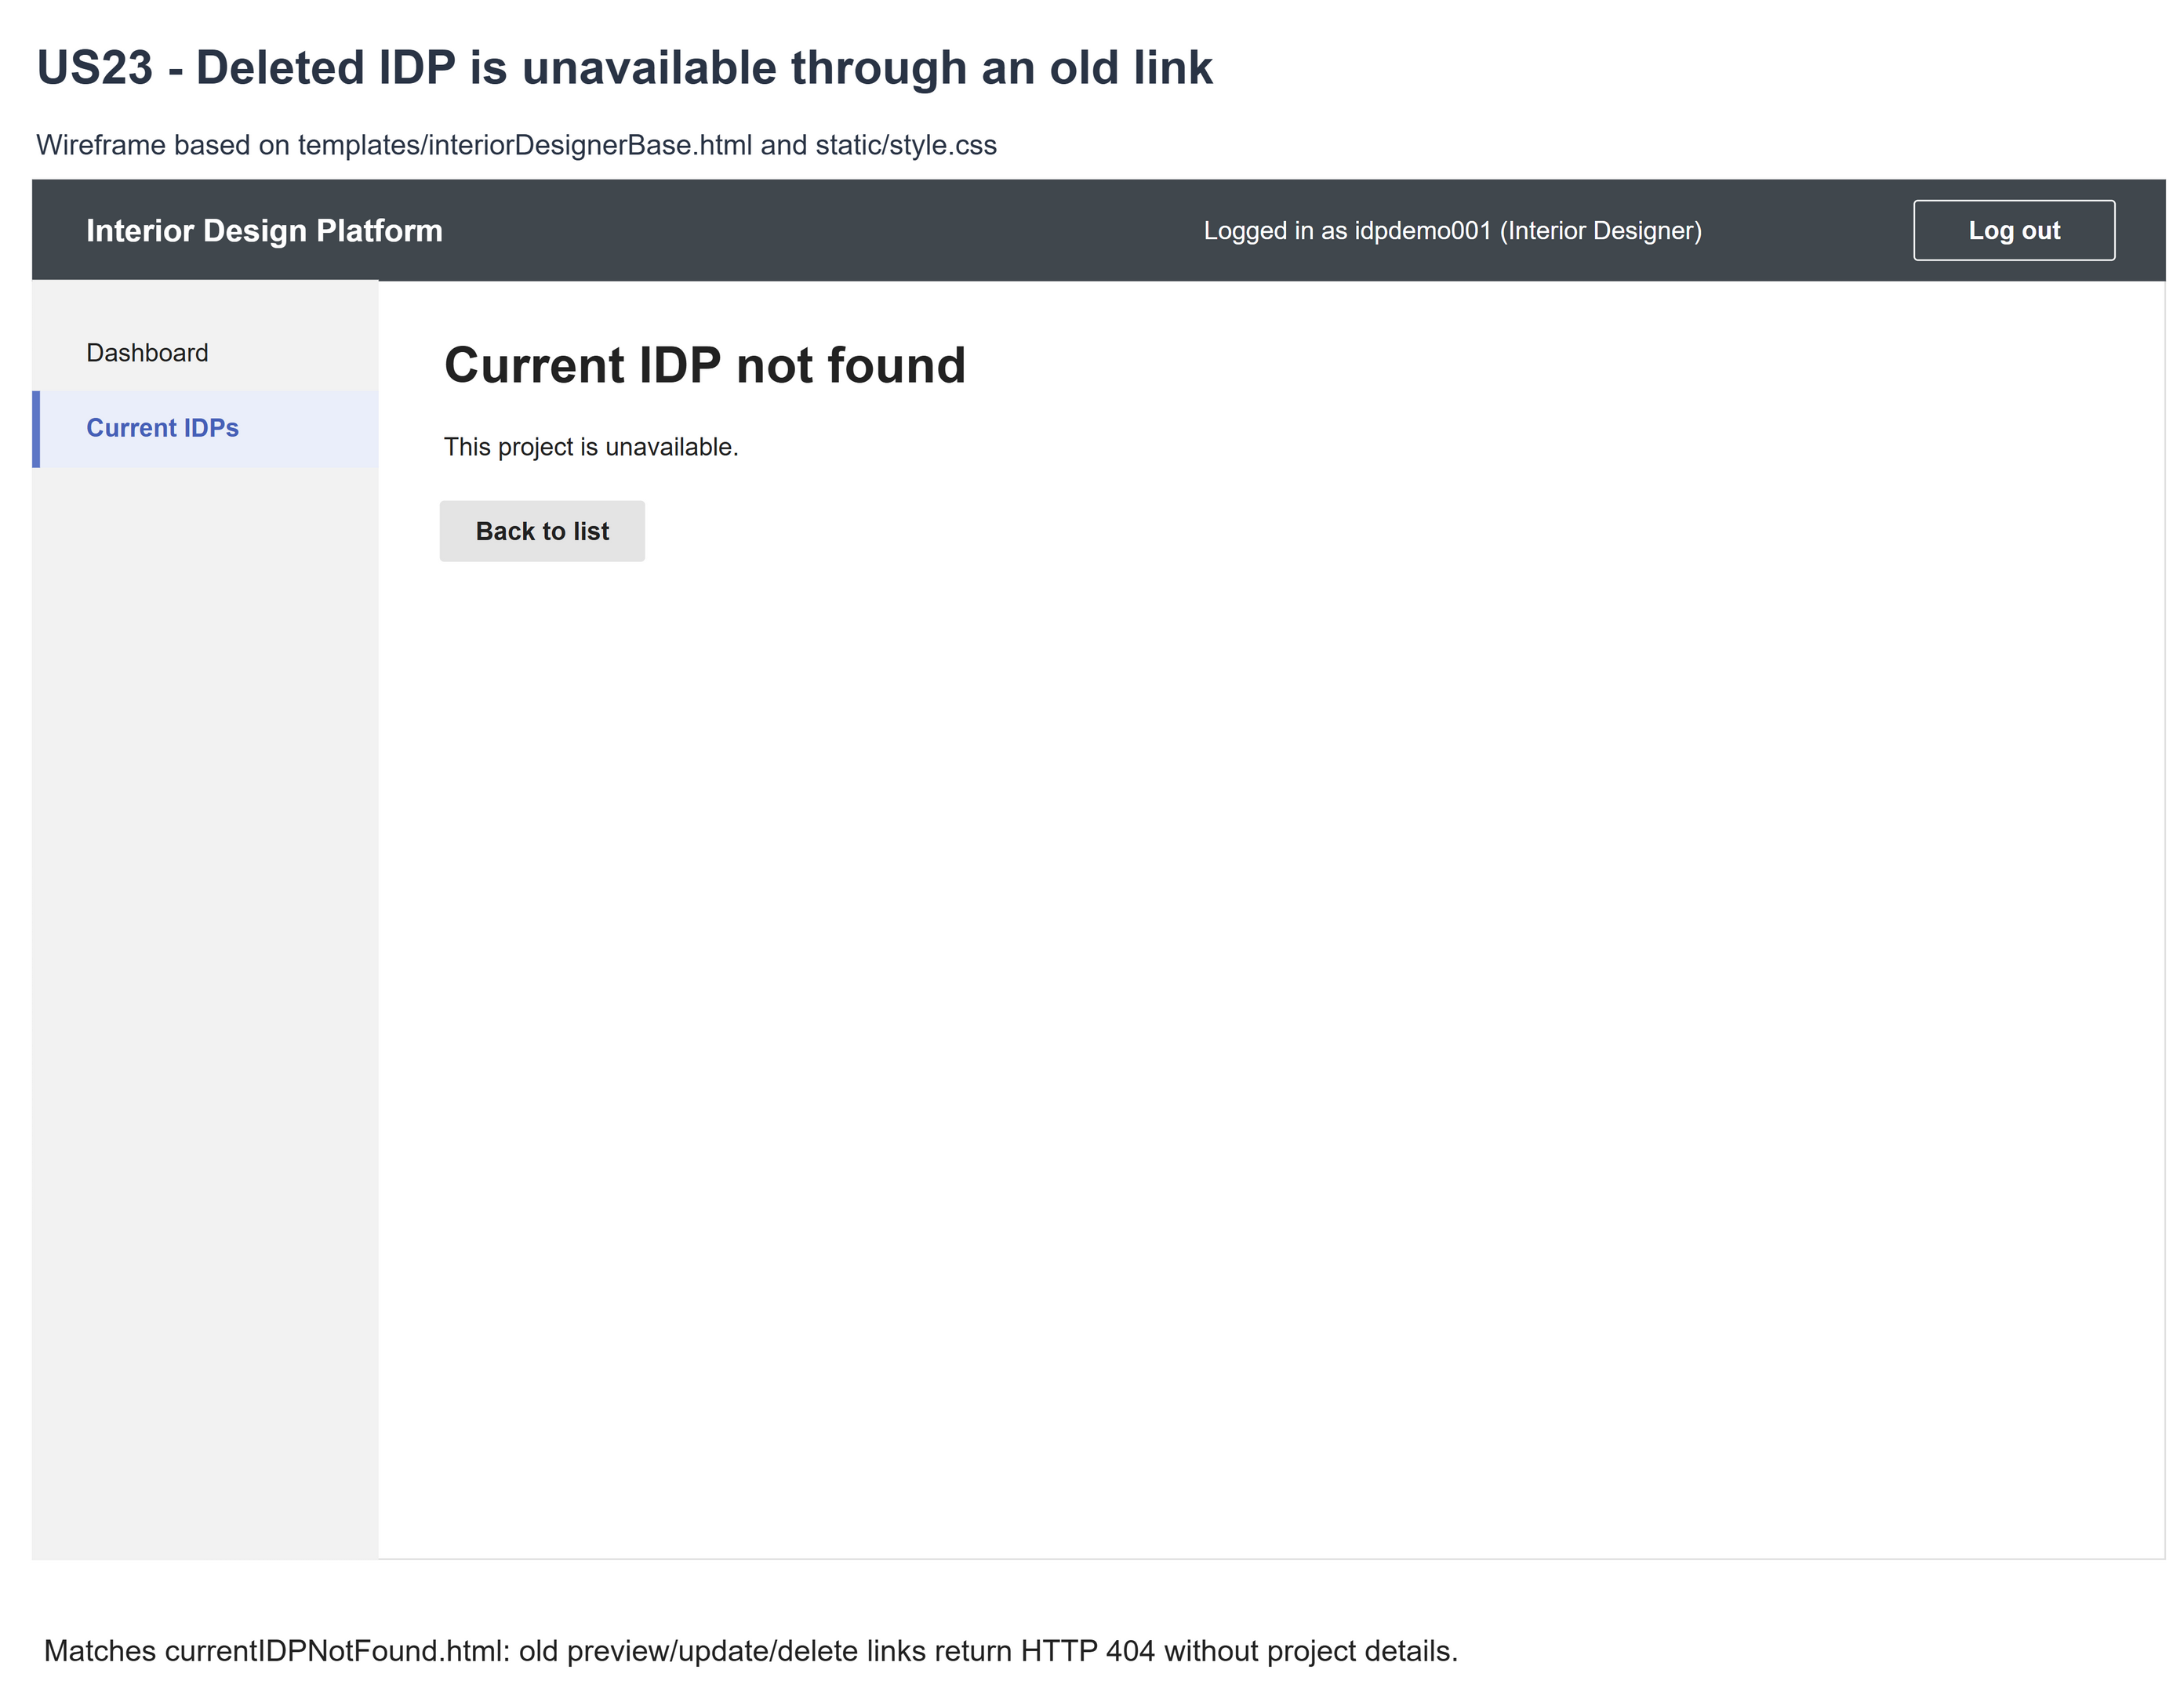
Figure 5: Wireframe 4d - Deleted IDP not found (US23)

5. B-C-E class diagram
The solid line means the boundary calls the controller. The dashed line means the controller uses the entity. Only the operations needed for this use case are shown. Delete is what the designer sees; Suspended is the stored status.
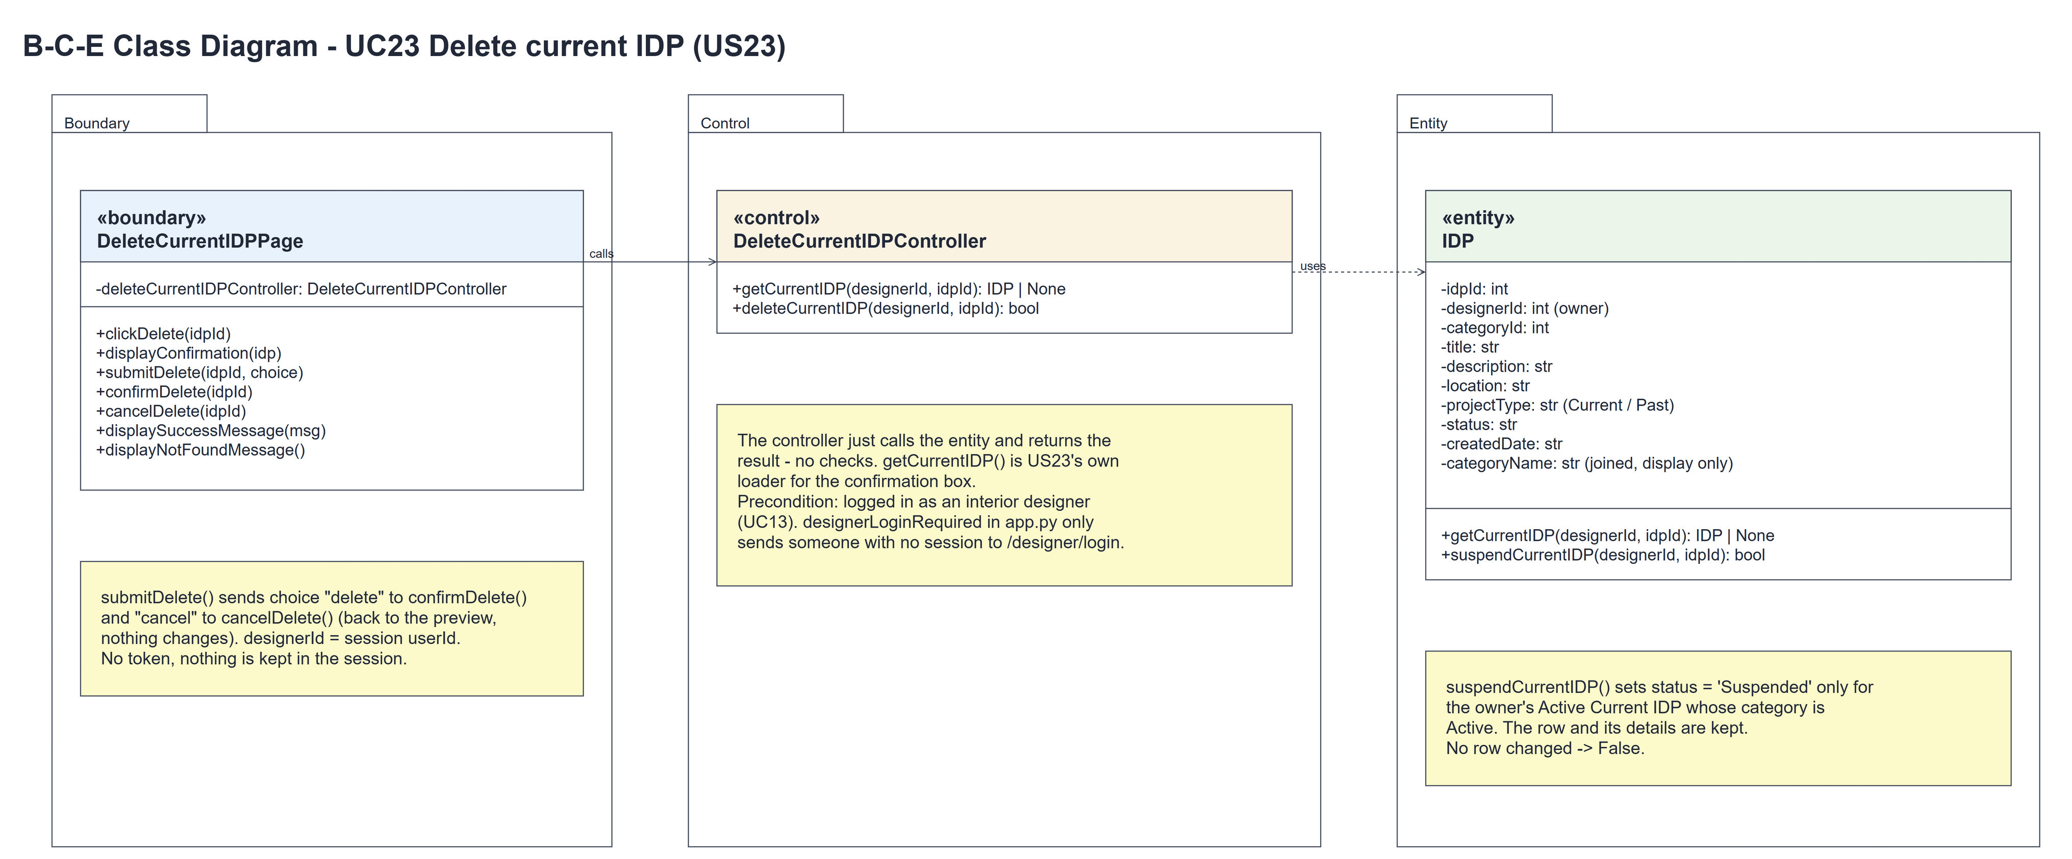
Figure 6: B-C-E class diagram for US23 Delete current IDP
Layer | Class | What it does
Boundary | DeleteCurrentIDPPage | The confirmation box. clickDelete(idpId) loads the IDP with getCurrentIDP() and shows displayConfirmation(idp) or displayNotFoundMessage() (HTTP 404). submitDelete(idpId, choice) sends "delete" to confirmDelete(idpId), which passes the session owner and idpId to the controller and shows displaySuccessMessage() or displayNotFoundMessage(), and "cancel" to cancelDelete(idpId), which goes back to the preview.
Control | DeleteCurrentIDPController | Controller for UC23. getCurrentIDP(designerId, idpId) is its own loader for the box and deleteCurrentIDP(designerId, idpId) just calls IDP.suspendCurrentIDP() and returns the result - no checks.
Entity | IDP | The only entity. getCurrentIDP() returns the owner's Active Current IDP in an Active category. suspendCurrentIDP(designerId, idpId) sets status = 'Suspended' only for that row; the details are kept; no row changed -> False.

6. Sequence diagram
The sequence diagram follows UC23. Clicking "Delete current IDP" calls the controller's own loader getCurrentIDP(designerId, idpId), which makes one call to IDP.getCurrentIDP() (steps 1-2); the first alt shows the confirmation box (step 3) or the not-found page (2a). When the box is sent, the outer alt picks the branch from choice: "delete" calls confirmDelete(idpId) and deleteCurrentIDP(designerId, idpId), which makes one call to IDP.suspendCurrentIDP() (steps 4-5), and the inner alt shows Current IDPs with the success message (step 6) or the not-found page (5a); "cancel" goes back to the preview (4a). No token is used and the details are not compared - the entity's check is enough.
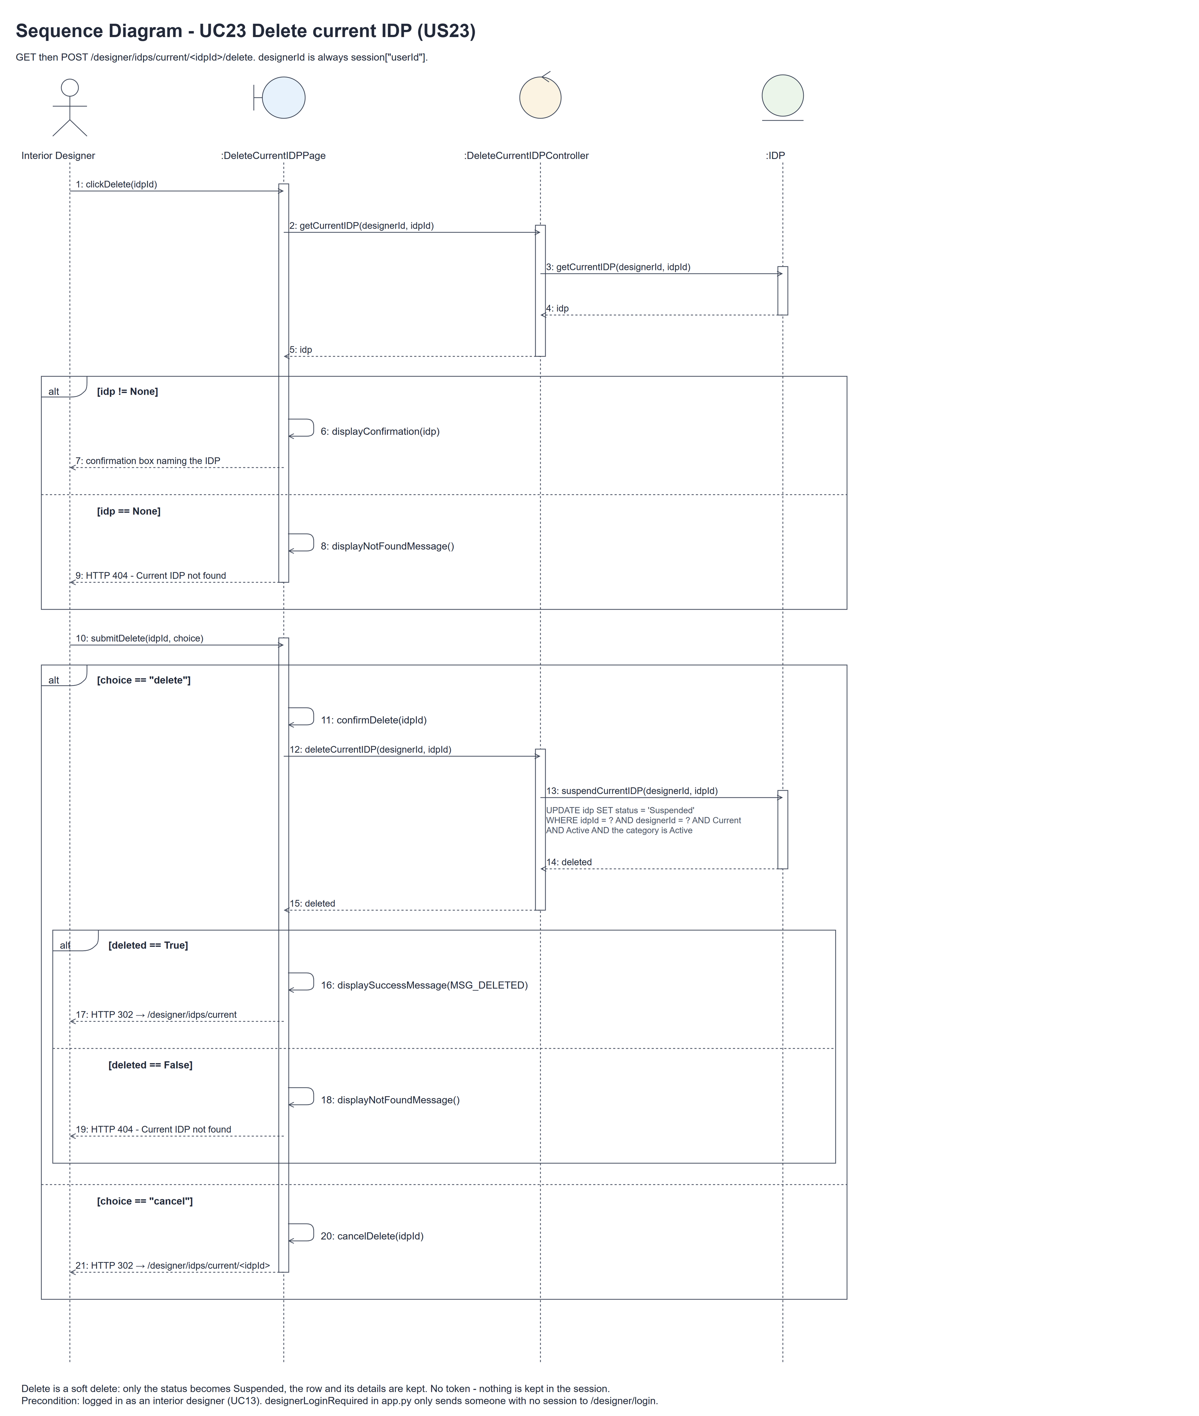
Figure 7: Sequence diagram for UC23 Delete current IDP

7. Test cases
Test data used below (the same as tests/test_us22_updateCurrentIDP.py, which tests/test_us23_deleteCurrentIDP.py reuses): designer accounts update22 (A) and other22 (B) / Design@123, made with UC8. IDP categories Living Room and Kitchen (Active) and Hidden (Suspended). A owns "Own Current Project" (Living Room, "Initial progress", Tampines) plus a Past IDP, a Suspended IDP and an IDP in Hidden. B owns "Other Designer Project".

7a. System test cases (black box)
Equivalence partitioning and boundary value analysis were used to pick the test data. Fill in "Actual result" and "Pass/Fail" after running each test.
Test ID | Scenario | Prerequisites | Test steps | Test data | Expected result | Actual result | Pass / Fail
TC23.1 | Open the confirmation box | Logged in as A. | 1. Open the preview / 2. Click "Delete current IDP" | Own Current Project | "Are you sure you want to delete Own Current Project?" with Delete and Cancel. Nothing deleted.
TC23.2 | Delete the IDP | The box is open. | 1. Click "Delete current IDP" in the box | - | "Current IDP deleted successfully" on Current IDPs; the IDP is gone from the list; the row is kept as Suspended.
TC23.3 | Cancel | The box is open. | 1. Click "Cancel" | - | Back on the preview; nothing changed.
TC23.4 | Last current IDP | A has only one current IDP. | 1. Delete it | One IDP | "Current IDP deleted successfully" and "You have no current IDPs to display".
TC23.5 | Old links | TC23.2 done. | 1. Open the old preview, update and delete URLs | Deleted idpId | HTTP 404 "Current IDP not found"; no details.
TC23.6 | IDP not available | Logged in as A. | 1. Open / post the delete URL of each IDP | B's IDP, A's Past, Suspended and Hidden IDPs, 999999 | HTTP 404; nothing deleted, no details shown.
TC23.7 | Not logged in | Not logged in. | 1. Open / post the delete URL | - | Sent to the designer login page; nothing deleted.
TC23.8 | Profile suspended after the box opened | The box is open; then A's profile is suspended (UC6). | 1. Click "Delete current IDP" / 2. Log out and log in again | - | The IDP is deleted - being logged in is the precondition (UC13), so it isn't checked again. The next login is refused. | The IDP was deleted (status Suspended). The next login showed "Invalid login details or access unavailable". | Pass
TC23.9 | Delete without opening the box first | Logged in as A. | 1. Post choice=delete to the delete URL directly | No token | The IDP is deleted - there is no confirmation token; the entity's check is enough. | The IDP was deleted (HTTP 302 to Current IDPs). | Pass
TC23.10 | Edited after the box opened | The box is open. | 1. Update the IDP in another tab (UC22) / 2. Confirm the old box | Changed title | The IDP is deleted (the details are not compared; HTTP 302 to Current IDPs). | The edited IDP was deleted (HTTP 302 to Current IDPs). | Pass
TC23.11 | Box sent twice / another designer's IDP | TC23.2 done; or logged in as B. | 1. Send the same Delete again / 2. As B, post choice=delete for A's IDP | - | HTTP 404 both times; nothing more is deleted. | HTTP 404 both times; nothing more was deleted. | Pass
TC23.12 | Other data kept | The box is open. | 1. Delete / 2. Look at the stored rows | - | Only the IDP's status becomes Suspended; its details, other IDPs, categories and accounts are unchanged.

7b. Unit test cases (for TDD)
These are written before the code (test-driven development) and run automatically in the CI pipeline. They cover normal inputs, abnormal inputs and boundary values. Each one matches a test function in tests/test_us23_deleteCurrentIDP.py (UT23.1 is test_ut23_1_...). "Pass" is from the pytest run on 10 November 2026.
Test ID | Class and method | Input / setup | Expected output | Type | Pass / Fail
UT23.1 | DeleteCurrentIDPController | Look at the class | Only getCurrentIDP() and deleteCurrentIDP() - no access-check method, no copy of the IDP's details and no login controller | Normal | Pass
UT23.2 | DeleteCurrentIDPController.getCurrentIDP() | A's own Active Current IDP | Returns it | Normal | Pass
UT23.3 | DeleteCurrentIDPController.getCurrentIDP() | B's IDP; A's Past, Suspended, Hidden IDPs; 999999 | None for each | Abnormal | Pass
UT23.4 | IDP.suspendCurrentIDP() | A, A's own IDP | True; only status changes to Suspended; the row is kept | Normal | Pass
UT23.5 | IDP.suspendCurrentIDP() | A, B's IDP | False; nothing changes | Abnormal | Pass
UT23.6 | IDP.suspendCurrentIDP() | A's Past, Suspended, Hidden or a missing IDP | False; nothing changes | Abnormal | Pass
UT23.7 | IDP.suspendCurrentIDP(designerId, idpId) | A, A's own IDP - only the two ids | True; the IDP is Suspended | Normal | Pass
UT23.8 | IDP.suspendCurrentIDP() | The IDP's title / description / location / category changed after the box opened | True - the delete doesn't compare the details; details kept | Abnormal | Pass
UT23.9 | IDP.suspendCurrentIDP() | Same delete twice | True, then False (the row is no longer Active) | Boundary | Pass
UT23.10 | DeleteCurrentIDPController.deleteCurrentIDP(designerId, idpId) | A, A's own IDP | True; getCurrentIDP() then returns None | Normal | Pass
UT23.11 | Both controller methods | InteriorDesignerLoginController would return None | No exception - each makes one entity call and returns the result | Abnormal | Pass
UT23.12 | DeleteCurrentIDPPage.clickDelete() | GET the delete URL of A's IDP | The box with the title, Delete and Cancel; no hidden token field; nothing stored in the session; no database change | Normal | Pass
UT23.13 | DeleteCurrentIDPPage.cancelDelete() | POST choice=cancel | Redirect to the preview; the IDP is unchanged | Normal | Pass
UT23.14 | DeleteCurrentIDPPage.confirmDelete() | POST choice=delete | "Current IDP deleted successfully" on Current IDPs; the old preview and update URLs give HTTP 404 | Normal | Pass
UT23.15 | DeleteCurrentIDPPage.confirmDelete() | Delete A's last current IDP | "You have no current IDPs to display" after the redirect | Boundary | Pass
UT23.16 | designerLoginRequired (app.py) | GET and POST, not logged in | Redirects to /designer/login; nothing changes | Abnormal | Pass
UT23.17 | Delete GET and POST | admin01 logged in on /login | The role isn't checked again (precondition UC13): the IDP isn't admin01's, so GET gives HTTP 404 and POST choice=delete deletes nothing | Abnormal | Pass
UT23.18 | Delete GET and POST | B's IDP; A's Past, Suspended, Hidden IDPs; 999999 | GET: HTTP 404 with no details. POST choice=delete: nothing deleted, HTTP 404 | Abnormal | Pass
UT23.19 | DeleteCurrentIDPPage.submitDelete() | POST choice=delete with no token field, or with an old / forged one | No token is checked: A's IDP is deleted (HTTP 302) | Abnormal | Pass
UT23.20 | DeleteCurrentIDPPage.submitDelete() | choice "", "yes" or "DELETE" | Nothing is deleted - only choice "delete" calls confirmDelete(); the IDP stays Active | Abnormal | Pass
UT23.21 | Delete POST after the box opened | Then: suspend A's account / profile / permission; or suspend the IDP, its category or make it Past | Account changes: not checked again, the IDP is deleted. IDP changes: nothing deleted, HTTP 404 | Abnormal | Pass
UT23.22 | Delete after a US22 edit | Open the box, save an edit (UC22), then confirm the old box | The edited IDP is deleted (HTTP 302) - the details are not compared | Abnormal | Pass
UT23.23 | IDP.suspendCurrentIDP() race | The category is suspended, or the IDP edited, just before the UPDATE | Category: False, nothing deleted, HTTP 404. Edit: the IDP is deleted | Abnormal | Pass
UT23.24 | DeleteCurrentIDPPage.confirmDelete() | The same Delete post sent twice | The second one deletes nothing more and gives HTTP 404 | Abnormal | Pass
UT23.25 | DeleteCurrentIDPPage.displayConfirmation() | Title "<script>alert(1)</script>" | Shown escaped, not run | Abnormal | Pass
UT23.26 | Session after deleting | Open the update form (UC22), then delete | Nothing about the IDP is kept in the session (no update or delete tokens) | Normal | Pass
UT23.27 | DeleteCurrentIDPPage.clickDelete() | A's profile suspended after logging in | Not checked again: the box still opens (HTTP 200) for this session | Abnormal | Pass
UT23.28 | Delete another designer's IDP | other22 logged in posts choice=delete for A's IDP | Nothing deleted - the entity only suspends the session owner's IDP; HTTP 404 | Abnormal | Pass
UT23.29 | GET safety / preview | GET ?choice=delete; PUT; A's preview | GET deletes nothing; PUT gives 405; the preview has the Delete link | Normal | Pass
UT23.30 | DeleteCurrentIDPPage.submitDelete() | POST choice=delete with forged designerId, idpId and status | Only A's IDP from the URL is suspended; B's IDP is unchanged | Abnormal | Pass
UT23.31 | DeleteCurrentIDPPage.displayConfirmation() | Description of 2000 Unicode characters | HTTP 200; nothing about the IDP is stored in the session cookie | Boundary | Pass

